Lab task 5.1

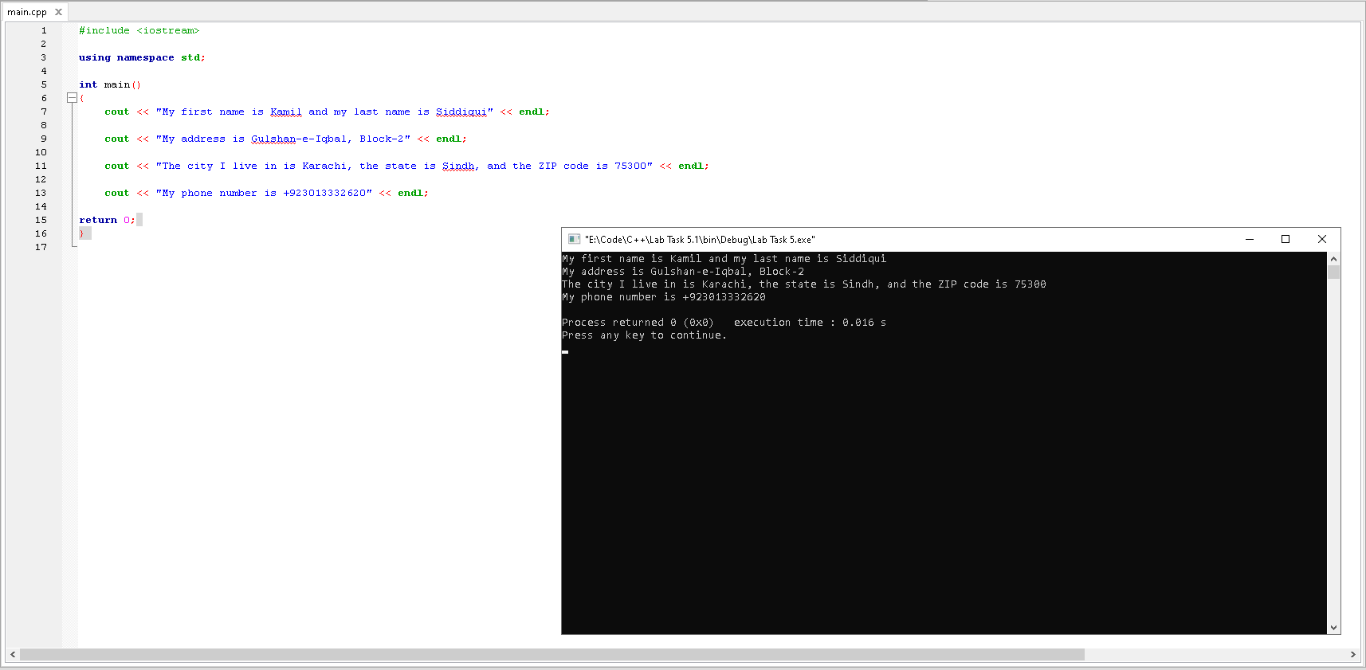

Observation: The program outputs the content within the quotation marks.

Lab task 5.2

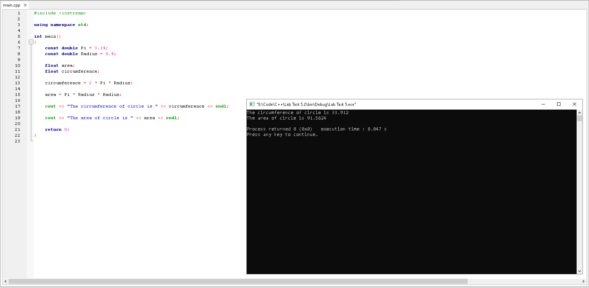

Observation: The program is initialized with two constants and two variables. The circumference and

area is calculated using the constants initialized earlier. The value of area and circumference is then

shown to the user with some wordings by the program.

Lab task 5.3

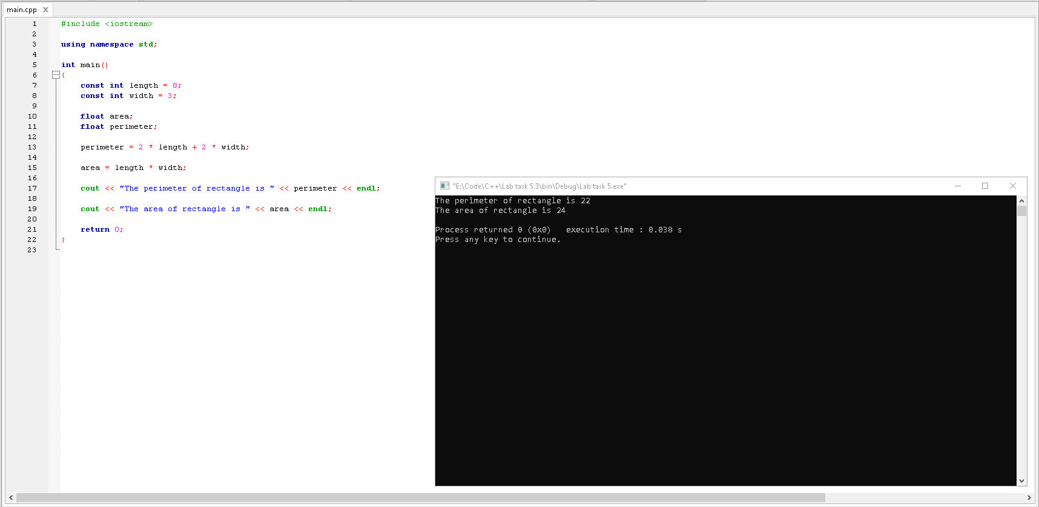

Observation: The program is initialized with two constants and two variables. The perimeter and area

is calculated using the constants initialized earlier. The value of area and perimeter is then shown to the

user with some wordings by the program.

Post Lab

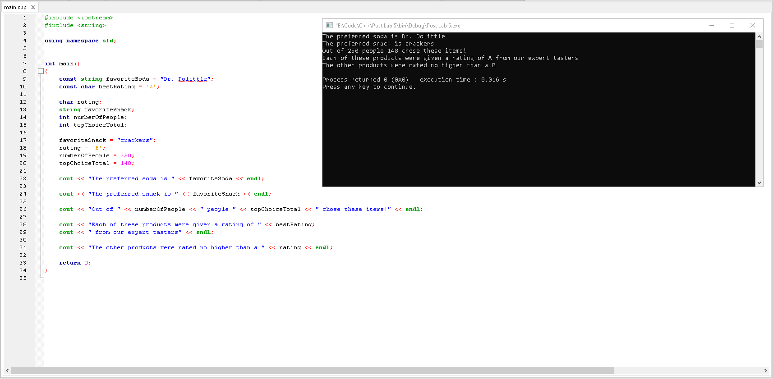

Observation: The program is initialized with two constants followed by initializing of variables and

Values in them after that. At the end, the program outputs a couple statements using those variables.

Exercise 2: No, it is not possible to change the choice of FAVIRITESODA by adding code within the main

Module since it is a constant

Exercise 3: Yes, it is possible to change the choice of favoriteSnack by adding code within the program

Since it is a variable